**PAN EUROPEAN COMPETITION**

**To Identify Potential Business Opportunities from the DANUBIUS-RI Research Infrastructure**

**PRIZE – Trip for two to Lisbon to attend the European Marine Day 2019**

**The Competition for Ideas**

DANUBIUS-RI (<http://www.danubius-ri.eu>) is a Pan European distributed environmental research infrastructure in the planning stages and aims to become operational by 2023. DANUBIUS-PP ([www.danubius-pp.eu](http://www.danubius-pp.eu)) a H2020 preparatory phase project that is developing the frameworks for a dedicated research infrastructure. This planned infrastructure, Danubius-RI is **committed to making river-sea systems work** and one of the main challenges is the evaluation of the societal and economic impact and the establishment of strong and sustainable links with industry and the business community.

The objective of this competition is to **identify ideas and build a proposal that will engage the business community** during the current planning phase through to the development and subsequent operational phase **and** lead to long-term partnerships.

The submitted proposal should draw from the experience of existing pan-European or international research infrastructures. As such it should take into account current and future trends in environmental technologies, big data science and societal and economic impact assessment at a local and pan-European scale.

**Competition Rules**

* The competition is **open to undergraduate and postgraduate business students** within instituitions linked with DANUBIUS-PP partners.
* Entries should be in the form of a **2000 word report** submitted in pdf format only to [email address] by 17:00 (GMT) by the **deadline, Tuesday 30th April 2019**. – late entries will not be accepted.
* All proposals must be an **original piece of work** which presents:

1. a well-researched and argued case for a business opportunity that could exploit outputs (data or informational) from the DANUBIUS-RI;
2. a convincing business proposition that could be utilised by Danubius-RI.

* The top ~~three~~ submission~~s~~ will receive travel and hotel accommodation for two people for two nights in Lisbon and will be invited to an award ceremony at the **prestigious European Marine Day in Lisbon in 2019** where their business plan will be presented to the European Marine Community
* All proposals will be assessed and ranked by a panel of experts from Danubius RI Partner Institutions and the Science and Technology Advisory Board– the decision of this panel is final and binding and canvassing will result in disqualification.

**1. The DANUBIUS research infrastructure**

Freshwater and marine systems are central to societal wellbeing, yet they face multiple and cummulative pressures from climate change, eutrophication and other natural and anthropogenic drivers at local and global scales. DANUBIUS-RI will be a distributed research infrastructure (see map below) that brings together world leading expertise and provide access to a range of River-Sea (RS) systems. It will provide facilities and expertise, to underpin a ‘one- stop shop’ for knowledge exchange, access to harmonised data, a platform for interdisciplinary research, education and training. Its aim is to provide a mechanism to address current and future questions regarding sustainable management and environmental protection across the continuum of RS systems.

* 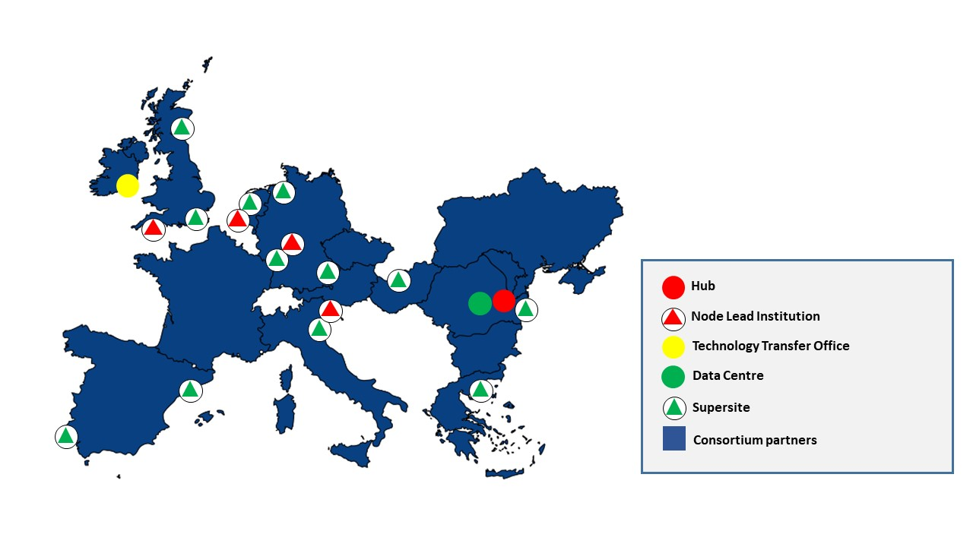

**Map summarising the key components of DANUBIUS-RI**

**2. The Perceived Opportunity**

* DANUBIUS-RI will deliver a fundamentally new approach to research to advance the goal of better-informed and holistically engaged environmental management of RS systems, particularly at the freshwater-marine interface. This requires world leading interdisciplinary research that has immediate societal relevance and impact in the freshwater and marine sciences. The research must span traditional disciplinary and geographic boundaries and be implemented in a consistent and quality assured framework. Recognising these needs, the concept of DANUBIUS-RI was developed, positively evaluated and included on the 2016 Roadmap of the European Strategy Forum on Research Infrastructures (ESFRI)[1].
* As with other RIs, DANUBIUS-RI presents a novel architecture with a distributed capacity and speciality in understanding River Sea systems. From experience, the scientific and economic advantage in operating as RIs in merit-based open-access[2] mode has prompted an evolution of national and macro-regional based initiatives towards fully pan-European and international organisations. Broad consortia that facilitate the formation of an RI allow the optimisation of the investment of both human and financial capital resources and the maximum impact and return to society. The RI system is also intrinsically more dynamic and responsive to the needs of a multidisciplinary approach increasingly required when addressing the so-called “grand challenges”[3] - these can be difficult to tackle in a sectorial way (economy vs. society vs. knowledge) or within the framework of academic disciplines alone.

1. ESFRI (The European Strategy Forum on Research Infrastructures) RIs are facilities, resources or services of a unique nature identified by European research communities to conduct top-level research activities in all fields.
2. Access based on research excellence of proposals
3. The Grand Challenges are difficult but important societal challenges that often require large scale interdisciplinary research to resolve, e.g. extreme environments such as flooding or drought.